Landscape Expansion Index (LEI)

1. **LEI** (landscape expansion index) can capture the information of the formation processes of a landscape pattern, which allows one to quantify the dynamic changes in two or more time points. It has been applied to the measurement of the urban expansion.

**Reference**: Liu XP, Li X, Chen YM, Tan ZZ, Li SY, Ai B (2010) A new landscape index for quantifying urban expansion using multi-temporal remotely sensed data. Landscape Ecol 25:671–682

1. LEI Tool

The LEI (Fig. 1) for a new patch can be defined and calculated through examining the characteristics of its buffer zone.

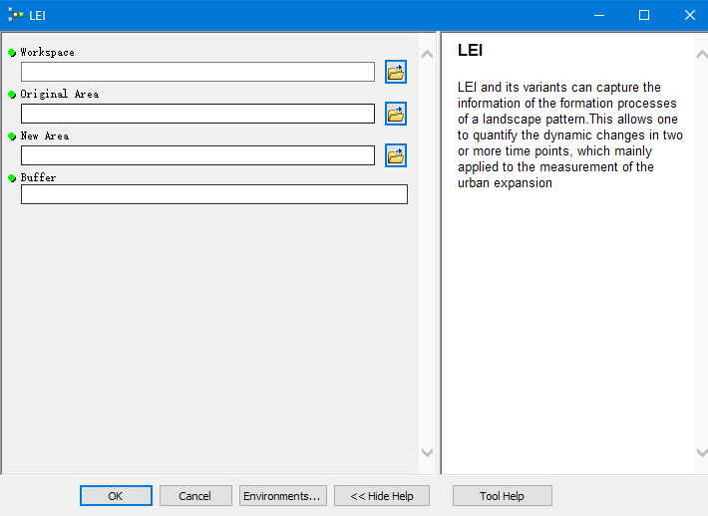

Fig. 1 LEI Tool

Environment: ArcGIS 10.2

Parameter:

1. Workspace: the folder or database, for example, .gdb or .mdb where data stored
2. Original Area: original or old area, for example, original town area
3. New Area: new area, for example, newly builded town area
4. Buffer: buffer distance
5. Demo:
6. Data: Old.shp, New.shp (the data should have the same coordinate system).

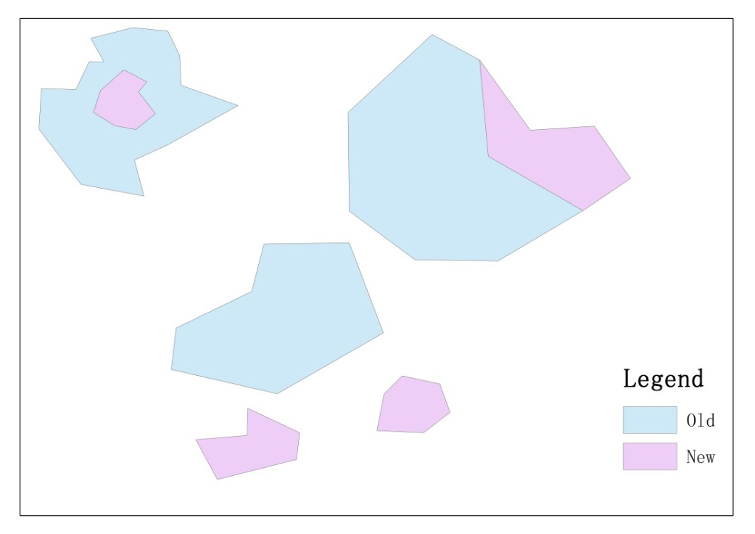

Fig 2 Test Data

1. Parameters Setting

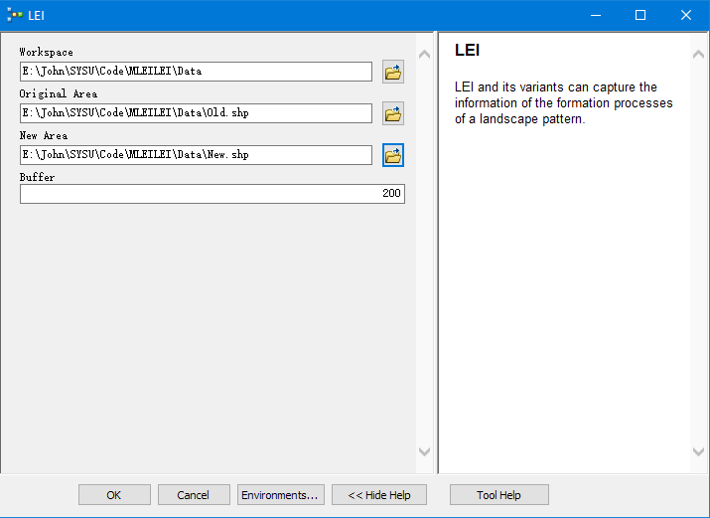

Fig 3 Parameters Setting

1. Result

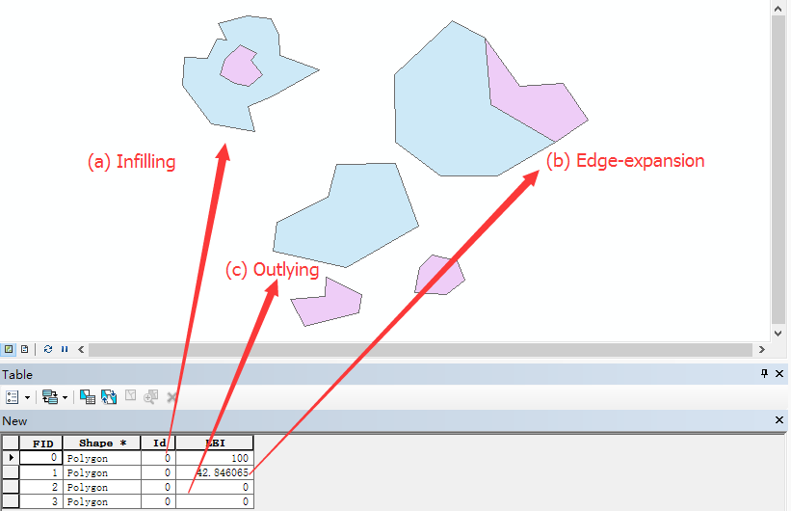

Fig 4 Result

1. Attention:
   1. Script Config: Right click the Script, select Properties, choose Source tab, correlate with LEI.py in Script File;

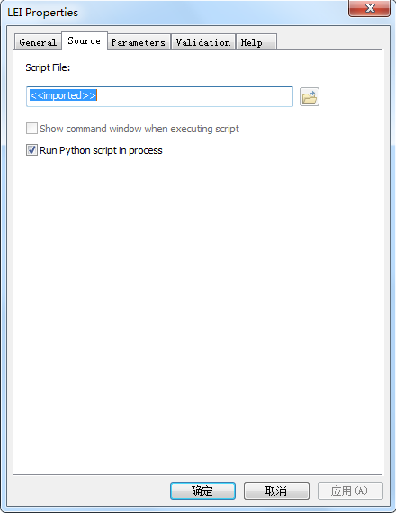

Fig 5 Binding Script

* 1. Keep the same coordinate system.